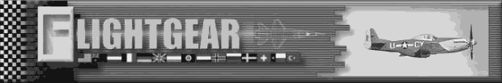

Features:
- The most beautifully rendered scenery and most accurate terrain elevation data for any publicly available flight simulator;
- Accurate positioning of the Sun, Moon and other astronomical objects;
- Navigate with VOR/ADF/DME and fly ILS approaches;
- Network support for multiple players;
- Supports many popular joysticks;
- Open source: Flight Gear is freely available.

What do I need to run Flight Gear?
Flight Gear does not require the most up-to-date CPU – a 266MHz Pentium-II machine running Linux or Windows should do just fine. However, Flight Gear requires a good 3D accelerator card with full OpenGL drivers to achieve smooth frame rates.

How to find more information
The largest source of Flight Gear information is our Web Site:
http://www.flightgear.org.

Downloads of Flight Gear are available for Windows and UNIX platforms. Visit
http://www.flightgear.org/Downloads/
for more information.

We can automatically let you know when Flight Gear is updated via our mailing lists. To join, send an email containing only the word “subscribe” to:
fgfs-announce-request@flightgear.org.

HELP WANTED!!
There are many ways to get involved with the Flight Gear project. If you'd like to get involved, we encourage you to find an area that interests you, and just go to town! To get started, visit the “Help Wanted” page on our Web site:
http://www.flightgear.org/Help/

What is Flight Gear?
Flight Gear is a free flight simulator project. It is being developed through the gracious contribution of source code and spare time by many talented people from around the globe. Among the many goals of this project are the quest to minimize short cuts and "do things right", the quest to learn and advance knowledge, and the quest to have better toys to play with.

The idea for Flight Gear was born out of a dissatisfaction with current commercial PC flight simulators. A big problem with these simulators is their proprietary nature and lack of extensibility. There are so many people across the world with great ideas for enhancing the currently available simulators, who have the ability to write code, and who have a desire to learn and contribute. Many people involved in education and research could use a spiffy flight simulator framework on which to build their own projects. Unfortunately, commercial simulators do not lend themselves to modification and enhancement. The Flight Gear project strives to fill these gaps.

We have a wide range of people interested and participating in this project. This is truly a global effort with contributors from just about every continent. Interests range from building a realistic home simulator out old airplane parts, to university research and instructional use, to simply having a viable alternative to commercial PC simulators.

We’ve licensed Flight Gear under the Gnu Public License, and thus have intentionally chosen to keep Flight Gear and its source code open, available, and free. In doing so, we are able to take advantage of the efforts of tremendously talented people from around the world. Contrast this with the traditional approach of commercial software vendors, who are limited by the collective ability of the people they can hire and pay. Our approach brings its own unique challenges and difficulties, but we are confident (and other similarly structured projects have demonstrated) that in the long run we can outclass our commercial "competition."

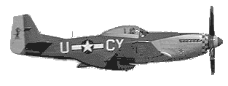
Personally, Flight Gear has been a great learning experience for me. I have been exposed to many new ideas and have learned a tremendous amount of "good stuff" in the process of discussing and implementing various Flight Gear subsystems. If for no other reason, this alone makes it all worth while.

Curtis Olson,
Flight Gear Project Manager

